**Get & Set the value of a property**

**Getting values of properties:**

There are **two** ways to get the value of property depending on value type (data or function value)

1. To get data value we run this **syntax**:

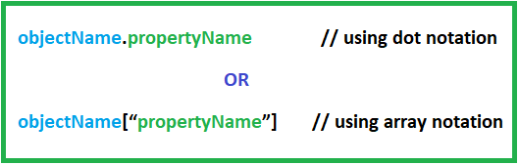

1. To Get function value we run this **syntax**:

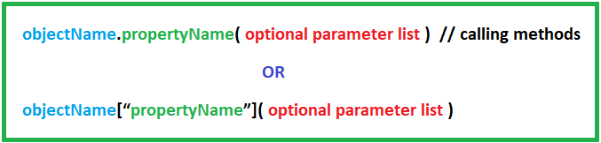

**Examples:**

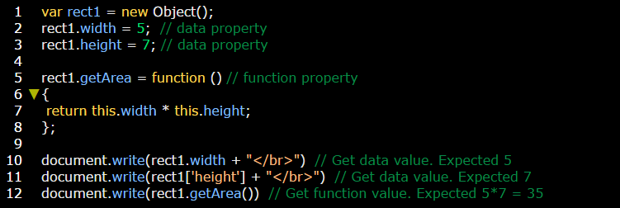

**Setting values of properties:**

There is **one** way to set the value of property (data or function value):

**Syntax:**

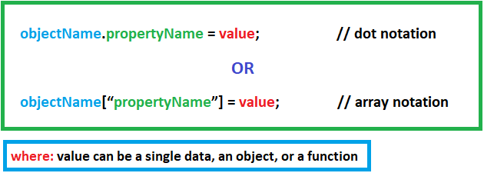

**Examples:**

